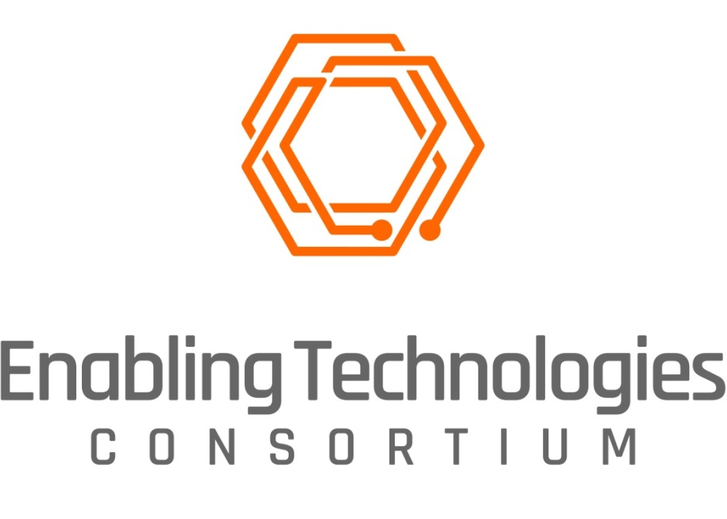

REQUEST FOR INFORMATION
Next Generation Capture – Wearables
December 2, 2019

Enabling Technologies Consortium™
Request for Information
Table of Contents

1 Introduction 3
1.1 About Enabling Technologies Consortium™ (ETC) 3
1.2 Request for Information 3
1.3 Disclaimer 3
1.4 RFI Contact Information 4
1.5 Anticipated Time Frames for Evaluation and Selection Process 4
2 Project Information 4
2.1 Possible Project Sponsors 4
2.2 Description 4
2.3 NGC - Wearables Requirements 6
2.3.1 Necessary Project Requirements 6
2.3.2 Additional Preferred Project Requirements 7
2.3.3 Licensing Requirements for Commercialized Product 7
3 Criteria for Evaluation 8
4 Respondent Profile (to be completed by RFI respondent) 9
4.1 Company/Organization Information 9
4.2 Primary Contact Person 9
4.3 Company/Organization Overview 9
4.4 Parent Corporation and/or Subsidiaries 9
4.5 Summary of Expertise 10
4.6 Standards Certifications 10
4.7 Goals and Strategic Vision 10
4.8 Miscellaneous 10
5 Company/Organization Response to RFI (to be completed by RFI respondent) 12
5.1 Proposal 12
5.2 Functional Requirements & Specifications 12
5.3 Estimated Timeline 13
5.4 Estimated Project Cost 13

Introduction

About Enabling Technologies Consortium™ (ETC)
The Enabling Technologies Consortium™ (ETC) is comprised of pharmaceutical and biotechnology companies collaborating on issues related to pharmaceutical chemistry, manufacturing, and control with the goal of identifying, evaluating, developing, and improving scientific tools and techniques that support the efficient development, and manufacturing of pharmaceuticals. The purpose of this consortium is to identify pro-actively high-value opportunities to deliver innovative technologies where the business case is compelling and collaboration with the broader external community is required.

Request for Information
Publication of this Request for Information (RFI) is the first step by ETC to solicit interest in collaborating together on a Next Generation Capture (NGC) Wearables Module. The information collected during the RFI process along with subsequent interviews will be used for evaluation purposes. Depending on the responses received ETC may choose to select a collaborator solely based upon their response to the RFI or may choose to refine project requirements and subsequently release a Request for Proposals (RFP) to aid in the collaborator selection process.

Disclaimer
The contents and information provided in this RFI are meant to provide general information to parties interested in developing the Next Generation Capture Wearables Module. The successful respondent selected by ETC at either the RFI stage or RFP stage (if applicable) will be required to execute an Agreement that will govern the terms of the project. When responding to this RFI, please note the following:
- This RFI is not an offer or a contract
- Responses submitted in response to this RFI become the property of ETC
- Respondents will not be compensated or reimbursed for any costs incurred as part of the RFI process
- Any questions received – and ETC’s responses to those questions – will be anonymized and made available to all respondents via our website
- Responses to RFIs should contain only high-level discussions of product development efforts and should not contain trade secrets or confidential information. ETC does not make any confidentiality commitments with respect to RFI submissions but agrees not to publicly distribute the RFI responses outside the consortium or share RFI responses with other respondents.
- ETC is not obligated to contract for any of the products or services described in this RFI
- ETC reserves the right to:
  - Accept or reject any or all proposals
  - Waive any anomalies in proposals
  - Negotiate with any or all bidders
  - Modify or cancel this RFI at any time

RFI Contact Information
All questions and inquiries regarding this RFI should be directed to:
Ms. Alexis Myers
ETC Secretariat
c/o Drinker Biddle & Reath, LLP
1500 K St NW
Washington DC, 20005-1209
(202) 842-8800
info@etconsortium.org
http://www.etconsortium.org/

Anticipated Time Frames for Evaluation and Selection Process
Issue RFI December 2, 2019
Questions on RFI due January 3, 2020
Responses to RFI due February 28, 2020
Invitations sent to respondents for presentation March 2020
Presentation to ETC by respondents March – April 2020
Select Finalists April 2020

Please submit your response electronically to the above address. Responses received after February 28th, 2020 will not benefit from full consideration and may be excluded from the selection process.

Project Information

Possible Project Sponsors
Abbvie Inc., AstraZeneca plc, Biogen Inc, Bristol-Myers Squibb Company, Eli Lilly & Company, Merck, Pfizer Inc., Takeda Pharmaceutical Company Ltd.

Description
Our industry is pursuing disruptive technical solutions to transform the way laboratory data is captured, stored and used to advance medicines. To that end, an industry working group (WG) was formed. This WG has been meeting for two years leading to the publication of this RFI. We envision a new and open capture platform that would interface with various modules depending on the type and phase of work being performed.

This RFI, however, is limited to a module that would enable a platform to interface with wearable devices that could be worn by scientists inside laboratories to enhance and complement our ability to capture information from experiments. A solution in this space would fill a significant unmet need within our industry to improve the efficiency and depth of the data captured from experiments. A technology leap in this space will speed medicines to market and positively impact human health and quality of life.

Data/information is generated by an array of scientists (chemists, engineers, biologists, etc.) in the laboratory through experiments on varying scales (µg - kg) working with chemicals, cells, and equipment with various readouts (digital / interfaced or gauges) through multiple handling and manipulation steps. The current methods to collect information are predominantly manual (written notebook or electronic notebook). The disadvantages with this are loss of detail, documenting after the fact, and transcribing information (not necessarily raw data). In addition, these methods lend a perspective on experiments based on our flawed observation and translation as opposed to a near-real-time feed of reviewable information.

The working group is sensitive to suggesting a specific design and unintentionally limiting ideas and/or responses to this RFI. However, for the purpose of stimulating responses to a technology space that is still emerging, the WG shares below its vision for a potential solution:

Scientists desire ease and convenience in capturing robust experimental results. These results could be recorded in a number of ways (i.e. unstructured, text, voice, image, etc.). The device the WG envisions would support all of the most common and efficient ways to capture these results. The WG imagines a device that could be worn on the head or chest. If worn on the head, the device should not obscure the scientists’ vision and must be inclusive of, or integrated with, laboratory safety equipment. The WG envisions a device that allows “no touch” capture of information. “No touch” capture could be achieved through voice commands or an augmented reality UI (user interface). The device should allow scientists to dictate observations while receiving feedback on the accuracy of the electronic translation. The device must also assist the wearer in aiming the camera to achieve an optimized image and video capture experience. The device should have the ability to interface with ‘apps’ to enable flexibility in collating and summarizing information. Finally, the device should have the ability to evolve and change and must strike a balance with users between functionality and an intuitive user interface.

NGC - Wearables Requirements

Necessary Project Requirements
- Device must operate on iOS (preferred) or Android Enterprise 8+
- Demonstrate a design that allows for the integration of multiple capability modules for the laboratory environment. Wearables is one of perhaps several modules that would work together to create the desired laboratory ecosystem.
- Confirm an open and modular architecture for data storage and platform services.
- Respondents must demonstrate sufficient flexibility in security levels and system access. The system must meet all regulatory requirements for security and audit trails.
- Solution must not require heavy client software installation or the use of client emulation.
- Solution must demonstrate the ability to integrate with other related scientific modules to be further defined by the WG (i.e., Notebook, Visualizations, Machine Learning).
- Wearable solution must allow users to capture video and images with minimum effort, working with common laboratory safety gear.
- System must allow users to dictate (voice) experiment design, preparation or results with sufficient accuracy AND the ability to see the transcription in real time to confirm and edit the translation.
- Device must be lightweight.
- Device cannot obscure the user’s vision.
- Device must allow captured information to move easily into other software modules within the ecosystem (i.e. notebook) as described in #6 above.
- Device should allow basic voice commands to launch an experiment record, close the record, capture and image, capture a video and dictate.
- Collaborate with the WG to finalize project scope.
- Selected respondent must partner with WG subject matter experts to finalize key user stories and establish and demonstrate an understanding of these scenarios.

Additional Preferred Project Requirements

- System should integrate with existing laboratory safety equipment (i.e. be attached to safety glasses).
- System should allow users to capture images and videos through alternate reality-enabled user interfaces, a single click and/or voice commands.
- System should leverage technology to ease the burden of capturing information to allow richer description of experiments. Alternative reality/virtual reality capabilities should approach 90 FPS.
- Users would like the device to dictate or read back to users as a virtual lab assistant.
- Device should include a telepresence capability.
- Device should support multiple languages.
- System should have the ability to translate technical synonyms.
- Wearable should have “eye tracking” capability to reduce ergonomic impact to users.

Licensing Requirements for Commercialized Product
- Software will be licensed to ETC participants at no cost during (i) development and (ii) a mutually agreed beta testing period.
- Thereafter, software will be available for licensing on a perpetual basis [and subscription basis at the option of ETC participants]. The vendor shall make available industry standard support.
- Software shall be available for self-hosting by (or on behalf of) the ETC participants even if the vendor elects to make a SaaS alternative available.
- Ownership of data generated on system resides with customer.

Criteria for Evaluation
The ETC will evaluate the responses to this RFI based on the vendor’s ability to:
- Provide responses reflecting a desire to participate in collaboration.
- Meet the functional, performance, and technical requirements described in this RFI as evidenced by the RFI response and presentations made to ETC.
- Provide a cost-effective solution that is compatible with the goals of the project.
- Demonstrate domain expertise and an ability to work collaboratively with the ETC working group in development of the capability and potential implementation in unique information technology ecosystems.
- Provide a superior level of customer service and technical support, both pre-installation and post-installation to clients.
- Discuss potential partnerships and current development efforts that show similarities to this request.
- Provide any additional capabilities that may differentiate them from other potential collaborators.

The ETC will not provide individual feedback to RFI respondents beyond the status of their proposal.

Respondent Profile (to be completed by RFI respondent)
Please provide information to the following:

Company/Organization Information
Company/Organization Name
Address
City
State
Country
Zip Code
Website

Primary Contact Person
Name
Title
Email address
Phone Number

Company/Organization Overview
Provide a brief overview of your company/organization including number of years in business, number of employees, nature of business, description of clients, and related products developed and commercialized to date.

Parent Corporation and/or Subsidiaries
Identify any parent corporation and or subsidiaries, if appropriate.

Summary of Expertise
Give a brief description of your company/organization’s expertise in the area/field related to this RFI. Include any experience working on projects with Consortia/Associations.

Standards Certifications
List any certifications currently held, including date received, duration, and renewal date.

Goals and Strategic Vision
Provide a summary of your company/organization’s short term and long term goals and strategic vision.

Miscellaneous
Please enter your response to each requirement using the guidelines provided in the tables below. If additional documentation or schematics are required to respond to a particular question, please answer the question as succinctly and accurately as possible and reference supplemental attachments.

Company/Organization Response to RFI (to be completed by RFI respondent)

Proposal

Functional Requirements & Specifications
Refer to the following Functional Requirements and Specifications checklist which summarizes the collective requirements and specifications by the member companies participating in the project.

Based upon your proposed approach to deliver a solution, provide a response to each checklist item along with comments and assign one of the following Codes to each item:
A | Current capability of existing product
B | Able to add capability as requested
C | Able to add capability with modification to ETC request
D | Unable to add capability

Feature | Requirement | Code | Vendor Comments
General: Required | Device must operate on iOS (preferred) or Android Enterprise 8+
General: Required | Demonstrate a design that allows for the integration of multiple capability modules for the laboratory environment. Wearables is one of perhaps several modules that would work together to create the desired laboratory ecosystem.
General: Required | Confirm an open and modular architecture for data storage and platform services.
General: Required | Respondents must demonstrate sufficient flexibility in security levels and system access. The system must meet all regulatory requirements for security and audit trails.
General: Required | System must enable detailed sharing of information between scientists and external collaborators within a single “experiment.”
General: Required | Solution must not require heavy client software installation or the use of client emulation.
General: Required | Solution must demonstrate the ability to integrate with other related scientific modules to be further defined by the WG (i.e., Notebook, Visualizations, Machine Learning).
General: Required | Wearable solution must allow users to capture video and images with minimum effort, working with common laboratory safety gear.
General: Required | System must allow users to dictate (voice) experiment design, preparation or results with sufficient accuracy AND the ability to see the transcription in real time to confirm and edit the translation.
General: Required | Device must be lightweight.
General: Required | Device cannot obscure the user’s vision.
General: Required | Device must allow captured information to move easily into other software modules within the ecosystem (i.e. notebook) as described in #7 above.
General: Required | Device should allow basic voice commands to launch an experiment record, close the record, capture and image, capture a video and dictate.
General: Required | Collaborate with the WG to finalize project scope.
General: Required | Selected respondent must partner with WG subject matter experts to finalize key user stories and establish and demonstrate an understanding of these scenarios.
General: Preferred | System should integrate with existing laboratory safety equipment (i.e. be attached to safety glasses).
General: Preferred | System should allow users to capture images and videos through alternate reality-enabled user interfaces, a single click and/or voice commands.
General: Preferred | System should leverage technology to ease the burden of capturing information to allow richer description of experiments. Alternative reality/virtual reality capabilities should approach 90 FPS.
General: Preferred | Users would like the device to dictate or read back to users as a virtual lab assistant.
General: Preferred | Device should include a telepresence capability.
General: Preferred | Device should support multiple languages.
General: Preferred | System should have the ability to translate technical synonyms.
General: Preferred | Wearable should have “eye tracking” capability to reduce ergonomic impact to users.

Estimated Timeline

Estimated Project Cost

