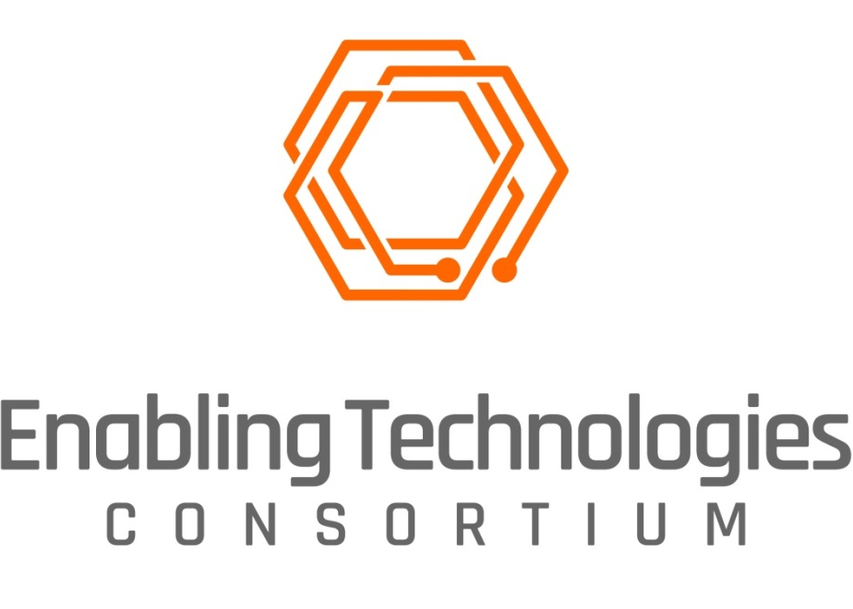
REQUEST FOR INFORMATION
Development of Solid Formulation Screening Workstation
February 24, 2021

Enabling Technologies Consortium™
Request for Information
Table of Contents

1 Introduction 3
1.1 About Enabling Technologies Consortium™ (ETC) 3
1.2 Request for Information 3
1.3 Disclaimer 3
1.4 RFI Contact Information 4
1.5 Anticipated Time Frames for RFI Process* 4
2 Project Information 5
2.1 Possible Project Sponsors 5
2.2 Description 5
2.3 Solid Formulation Screening Workstation Requirements 6
2.3.1 Necessary Requirements/Features 6
2.3.2 Optional Requirements/Features 6
2.3.3 Availability Requirements 7
2.3.4 Licensing Requirements for Commercialized Product 7
3 Criteria for Evaluation 8
4 Respondent Profile (to be completed by RFI respondent) 8
4.1 Company/Organization Information 8
4.2 Primary Contact Person 8
4.3 Company/Organization Overview 9
4.4 Parent Corporation and/or Subsidiaries 9
4.5 Summary of Expertise 9
4.6 Standards Certifications 10
4.7 Goals and Strategic Vision 10
4.8 Miscellaneous 10
5 Company/Organization Response to RFI (to be completed by RFI respondent) 11
5.1 RFI Response/Proposal 11
5.2 Functional Requirements & Specifications 11
5.3 Estimated Timeline 12
5.4 Estimated Project Cost 12
5.5 Commercialization and Support 13

Introduction

About Enabling Technologies Consortium™ (ETC)
The Enabling Technologies Consortium™ (ETC) is comprised of pharmaceutical and biotechnology companies collaborating on issues related to pharmaceutical chemistry, manufacturing, and control with the goal of identifying, evaluating, developing, and improving scientific tools and techniques that support the efficient development and manufacturing of pharmaceuticals. The purpose of this consortium is to identify pro-actively high-value opportunities to deliver innovative technologies where the business case is compelling and collaboration with the broader external community is required.

Request for Information
Publication of this Request for Information (RFI) is the first step by ETC to solicit interest in collaborating together on a Solid Formulation Screening Workstation project. The information collected during the RFI process along with subsequent interviews will be used for evaluation purposes. Depending on the responses received ETC may choose to select a collaborator solely based upon their response to the RFI or may choose to refine project requirements and subsequently release a Request for Proposals (RFP) to aid in the collaborator selection process.

Disclaimer
The contents and information provided in this RFI are meant to provide general information to parties interested in development of a Solid Formulation Screening Workstation. In the event ETC decides to collaborate with a third party on this project, the third party will be required to execute an Agreement with ETC that will govern the terms of the project. When responding to this RFI, please note the following:
- This RFI is not an offer or a contract
- Responses submitted in response to this RFI become property of ETC
- Respondents will not be compensated or reimbursed for any costs incurred as part of the RFI process
- If ETC receives and responds to questions from RFI respondents, ETC reserves the right to anonymize the questions and make the questions and ETC’s responses available to all respondents via our website
- Responses to RFIs should contain only high-level discussions of product development efforts and should not contain trade secrets or confidential information. ETC does not make any confidentiality commitments with respect to RFI responses but agrees not to publicly distribute RFI responses outside of ETC or share RFI responses with other respondents.
- ETC is not obligated to contract for any of the products and services described in this RFI
- ETC reserves the right to:
  - Accept or reject any or all responses
  - Waive any anomalies in responses
  - Negotiate with any or all bidders
  - Modify or cancel this RFI at any time

RFI Contact Information
All questions and inquiries regarding this RFI should be directed to:
Ms. Fatou Sarr
ETC Secretariat
C/o Faegre Drinker Biddle & Reath, LLP
1500 K St NW
Washington DC, 20005-1209
(202) 230-5148
info@etconsortium.org
http://www.etconsortium.org/

Anticipated Time Frames for RFI Process*
Issue RFI February 24, 2021
Questions on RFI due March 15, 2021
ETC responds to any RFI questions April 1, 2021
Responses from potential collaborators due April 15, 2021
Invitations sent to respondents for presentation (if applicable) May 1, 2021
Presentation to ETC by respondents (if applicable) May 2021
Release RFP or select a collaborator (if applicable) May/June 2021
*Dates subject to change without notice

Please submit your response electronically to the above address. Responses received after April 15 may not benefit from full consideration and may be excluded from the selection process.

Project Information

Possible Project Sponsors
Bristol Myers Squibb, Eli Lilly, Genentech, Takeda, and Pfizer

Description
The Solid Formulation Screening Workstation envisioned utilizes automation and robotics to help define the formulation and process for solid dosage forms such as tablets and capsules.

The need: current state of the art is mostly manual, predominantly empirical, and is both time and resource consuming. An opportunity exists to replace these existing workflows with efficient robotic systems.

This workstation is expected to:
- Be a critical and routine part of early development workflow for all small molecule compounds making a transition from drug discovery to development
- Replace existing business critical and routine workflows with lower full-time employee (FTE) burden, bench space, time, and material requirements

Potential customers/users:
- Generic companies
- Brand companies
- CROs and CMOs

Solid Formulation Screening Workstation Requirements

Necessary Requirements/Features
ETC participants are seeking to collaborate with a third party to conceptualize and develop a commercially-available product that will be transformative for critical business operations in the pharmaceutical industry based upon the following attributes and capabilities:

Key attributes:
- Automated
- Robotic
- Enables high throughput screening
- Uses low quantities of material
- Benchtop
- Able to run pre-defined screening protocols
- Able to include decision making in running sequential pre-defined screening protocols

Capabilities:
- Excipient compatibility testing, both 1:1 mixtures of drug:excipient and n-1 testing;
- Polymorphic form screening, i.e., trying different polymorphic forms (if more than one form exists) of the active pharmaceutical ingredient (API) in a drug product formulation to assess relative advantages and merits;
- Dispensing small quantities of different types of excipients and APIs;
- Mixing under conditions that represent lab and pilot pharma scale processes;
- Optionally addition of water in small, tunable quantity and rate while mixing;
- Optionally heat and/or vacuum dry the mixed contents if water was added;
- Optionally apply pressure to compact the dry blend after mixing; and
- Transfer the prepared material to another robot for storage at pre-defined temperature and humidity combination(s) chamber (the chamber can be custom prepared or purchased commercially – it is not a part of this RFI).

Optional Requirements/Features
Capabilities:
- Addition of water in small, tunable quantity and rate while mixing;
- Heat and/or vacuum dry the mixed contents if water was added; and
- Application of pressure to compact the dry blend after mixing.

Availability Requirements
When a project is ultimately launched, ETC anticipates the creation and availability of prototype(s) for evaluation to aid in the design of the workstation within the first two (2) years of the project. ETC participants can help with beta testing, if mutually agreed, on terms mutually agreed. While the ETC project team’s membership spans both Europe and the US, it is envisaged that testing will occur only within the US.

Following conclusion of the project, it is expected that a commercial version of the instrument will be available and supported within approximately one (1) year. ETC participants provide no guarantee or assurance of purchase or adoption at a future time.

Licensing Requirements for Commercialized Product
- Any required software will be licensed to ETC participants at no cost during (i) development and (ii) a mutually agreed beta testing period.
- Thereafter, software will be available for licensing on a perpetual basis and subscription basis at the option of ETC participants.
- Software shall be available for self-hosting by (or on behalf of) the ETC participants if required.
- The vendor shall make available industry standard support.
- Ownership of data generated on system resides with the customer.

Criteria for Evaluation
The ETC will evaluate the responses to this RFI based on the respondent’s ability to:
- Provide response with desire to participate in collaboration.
- Meet the functional, performance, and technical requirements described in this RFI as evidenced by the RFI response and presentations made to ETC.
- Provide a cost-effective solution that is compatible with the goals of the project.
- Demonstrate domain expertise and an ability to work collaboratively with the ETC in development of Solid Formulation Screening Workstation.
- Provide a superior level of customer service and technical support, both pre-installation and post-installation to clients.
- Discuss potential partnerships and current development efforts that show similarities to this RFI.
- Provide any additional capabilities that may differentiate them from other potential collaborators.

The ETC will not be able to provide individual feedback to RFI respondents beyond the status of their response to this RFI.

Respondent Profile (to be completed by RFI respondent)
Please provide information to the following:

Company/Organization Information
Company/Organization Name
Address
City
State
Country
Zip Code
Website

Primary Contact Person
Name
Title
Email address
Phone Number

Company/Organization Overview
Provide a brief overview of your company/organization including number of years in business, number of employees, nature of business, description of clients, and related products developed and commercialized to date.

Parent Corporation and/or Subsidiaries
Identify any parent corporation and or subsidiaries, if appropriate.

Summary of Expertise
Give a brief description of your company/organization’s expertise in the area/field related to this RFI. Include any experience working on projects with Consortia/Associations.

Standards Certifications
List any certifications currently held, including date received, duration, and renewal date.

Goals and Strategic Vision
Provide a summary of your company/organization’s short term and long term goals and strategic vision.

Miscellaneous
Please enter your response to each requirement using the guidelines provided in the tables below. If additional documentation or schematics are required to respond to a particular question, please answer the question as succinctly and accurately as possible and reference supplemental attachments.

Company/Organization Response to RFI (to be completed by RFI respondent)

RFI Response/Proposal
Please provide your RFI response below. Feel free to include any supplementary material as attachments via email when you submit your response.

Functional Requirements & Specifications
For each of the Device Requirements specified in Section 2.3.1, please fill out the table below. You can refer to each requirement listed in Section 2.3.1 by the “Req” number provided. For each feature of your proposed solution, please assign them one of the following Codes from the table below along with any comments you may have:
A | Current capability of existing product
B | Able to add capability as requested
C | Able to add capability with modification to ETC request
D | Unable to add capability

Feature | Requirement | Code | Vendor Comments

Estimated Timeline

Estimated Project Cost
The overarching goal of ETC is to help bring innovative technologies to the commercial marketplace in partnership with third parties. Aligned with that goal, participating ETC members will provide resources in the form of funding and subject matter expertise to support the development of this project. While ETC will entertain all proposals in general when partnering with a commercial vendor, any monetary resources provided by ETC should be considered seed funding towards development with the collaborator investing as well; for academic or non-profit partnerships, any monetary contributions by ETC should be considered “Direct Cost Only” awards. Any indirect costs by the third party are subject to negotiation and not guaranteed.

For the Solid Formulation Screening Workstation project, the financial contribution from ETC is estimated to be approximately $100,000 USD per year with the expectation that the third party will invest in the project as well. In-kind contributions, including technical expertise, discussions, and guidance, would be the predominant form of investment by ETC companies towards this project.

Please describe below project costs, including not only the total project costs but also costs to be paid by ETC and any costs borne by your organization (if applicable). All projects awarded by ETC are fixed cost engagements paid in U.S. Dollars.

Commercialization and Support
The overarching goal of ETC is to help bring innovative technologies to the commercial marketplace in partnership with third parties. Aligned with that goal ETC looks to collaborate on projects which will result in products that are commercially available and supported in the marketplace. With most projects, all commercialization rights will reside with the collaborator; ETC will not assume ownership of any intellectual property (IP) developed by the collaborator nor expect royalties from future commercial sales.

Please describe your organization’s plans for commercialization and support of this technology following the successful conclusion of this project – be sure to limit your response to non-confidential information (see Section 1.3). If your organization is not a commercial entity (e.g., academic or non-profit), please describe any plans related to the availability of the technology following the successful conclusion of the project.

